**Data visualization Summary Report**

**Overview**

This Power BI dashboard offers a comprehensive snapshot of Superstore’s performance across product lines, customer segments, time periods, and shipping methods. The objective is to uncover data-driven insights that support more effective business decisions around product strategy, marketing, logistics, and customer engagement.

**Profitability by Product Sub-Category**

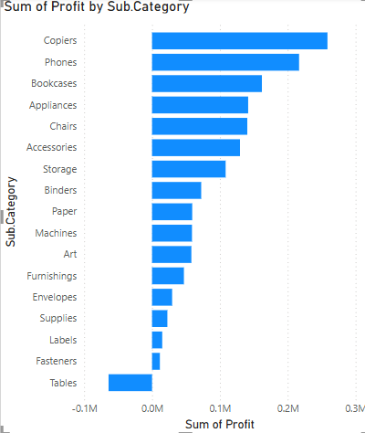

The analysis highlights a clear distinction in profit performance:

* **Top Performers**: *Copiers* and *Phones* are generating the highest profits—making them strategic products for continued investment and promotional focus.
* **Underperformers**: *Tables* are showing a **net loss**, with *Fasteners* and *Labels* also contributing minimal or negative profits.

**Sales Growth Over Time**

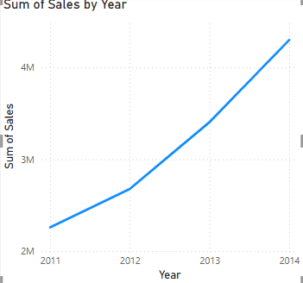

Year-over-year growth is evident, with sales climbing steadily from 2011 through 2014:

* Revenue nearly doubles in this span, indicating strong market traction.

**Performance by Customer Segment**

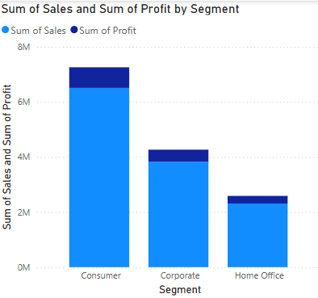

* Consumer Segment: Dominates both revenue and profit generation.
* Corporate Segment: Moderately successful, with opportunities to improve margin.
* Home Office: Trails in both sales and profit contribution.

**Shipping Mode Analysis**

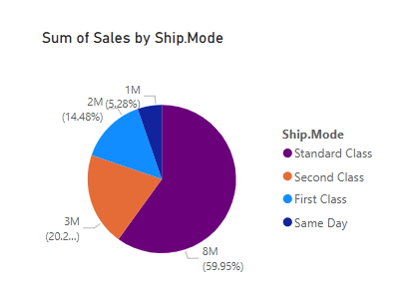

* *Standard Class* shipping accounts for ~60% of sales, making it the most popular and impactful delivery method.
* *Second Class* and *First Class* hold smaller shares, while *Same Day* represents a minimal portion.

**Discounts vs. Sales Behaviour**

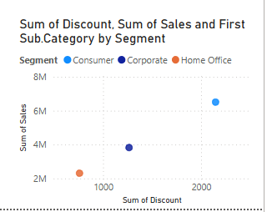

The scatter plot (Discount vs. Sales by Segment) reveals:

* Discounts drive sales in the *Consumer* segment more effectively than in others.
* In contrast, the *Home Office* segment doesn't respond well to discounting, showing low sales despite moderate discounts.